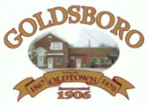

**Goldsboro Town Council Meeting**

**Sept. 10, 2024**

**\*Subject to Change**

**Open Meeting - Pledge of Allegiance**

**Approval of Minutes – Aug 2024** **minutes**

**Treasurer’s Report**

**Public Works Report**

**Old Business**

**New Business**

* **Ordinance 2024-04 Establish Sewer Rates (Intro only)**
* **Ordinance 2024-05 Sewer Rates Defined (Intro Only)**

**Council Comments**

**Sheriff’s Dept Report**

**Town Manager Report**

**Upcoming Events**

**Fall Fest Sept 29th**

**Trunk or Treat Oct 31st**

**Adjourn.**

**Next Goldsboro Town Council Meeting Oct. 8th, 2024 (PH Sewer Rates)**